WH&S Management Plan

Purpose

This purpose of this plan is to:

* Minimize potential risks.
* Recognize existing risks and determine actions that will prevent injury.
* Evaluate the efficiency of actions taken to reduce risks.

This plan will assist Yeet Ltd in meeting its obligations in accordance with work health and safety legislation.

This plan applies to all Yeet Ltd’s employees and to other persons at risk from work carried out at Yeet Ltd’s workplaces. Failure to comply with the requirements of this Plan may lead to disciplinary action.

Work Health and Safety (WHS) Policy

The Statement of Commitment and the Implementation of Policy Commitment provide the overarching direction Yeet Ltd will follow in pursuit of workplace health and safety outcomes. These commitments are:

**Statement of Commitment**

Yeet Ltd is committed to providing a workplace that enables all work activities to be carried out safely. We will take all reasonably practicable measures to eliminate or minimize risks to health, safety and welfare of workers, contactors, visitors, and anyone else who may be affected by our operations.

We are committed to ensuring we comply with the *Work Health and Safety Act 2011* (the Act). We will also comply with any other relevant legislation, applicable Codes of Practice and Australian Standards as far as possible.

**Implementation of Policy Commitment**

Yeet Ltd is committed to ensuring, so far as is reasonably practicable, the health and safety of its works while they are at work, and that the health and safety of other persons is not put at risk from our operations. This will be achieved by:

* providing a safe working environment
* resolving existing and new risks and hazards.
* Actively search for new risks to prevent injury.

Duty of Care

A Person Conducting a Business or Undertaking (PCBU) has the primary duty of care to ensure:

* All employees are safe whilst at work.

Yeet Ltd is a PCBU.

Responsibilities

**Managers and Leaders**

Managers and leaders are responsible for providing a workplace that is, as far as reasonably practicable, a safe and healthy workplace for workers and visitors, in particular in the areas of their control. This includes:

* modelling health and safety leadership
* demonstrating a commitment to good health and safety performance
* Ensuring risks and hazards are identified and correct actions are taken place.

**Workers**

Workers must take reasonable care for their own health and safety while they are at work, and take reasonable care that their acts or omissions do not adversely affect the health and safety of other persons.

On a day to day basis, this includes:

* ensuring their own personal health and safety, and that of others in the workplace
* complying with any reasonable directions (such as safe work procedures, wearing personal protective equipment) given by management that relates to health and safety
* Reporting new hazards to management.

It is acknowledged that, in accordance with the Act, a worker may cease, or refuse to carry out work if they have a reasonable concern the work would expose the worker to a serious risk to their health and safety.

**Contractors**

Contractors, sub-contractors and self-employed persons are defined as “workers” under the WHS Act if they carry out work in any capacity for Yeet Ltd. They are required to:

* Follow correct procedures issued by the company.
* Ensure their personal safety and that of those around them.

**Health and Safety Experts**

The following is a list of nominated workplace health and safety experts, who may be called on to assist with any aspect of this workplace health and safety management plan.

* Bill Cosby

WHS Risk Assessment:

The purpose of any WHS risk assessment is to ensure that, for any identified hazards, appropriate control measures are implemented in order to protect workers, contractors and visitors from risks to their health, safety and welfare.

Control measures for WHS hazards should be implemented as required using the following hierarchy of control, in order of preference these measures relate to:

* elimination (removal of the hazard)
* substitution (substitute the hazard for something which is less hazardous e.g. replace a hazardous chemical with one within is not hazardous)
* isolation (isolate the hazard from people e.g. place a noisy piece of equipment in another location)
* engineering (e.g. guarding on machinery)
* administrative (e.g. provision of training, policies and procedures, signage)
* personal protective equipment (e.g. use of hearing , eye protection, high visibility vests).

Outcomes of risk assessments will be documented and the control measures reviewed at least annually or earlier should a task or activity be the subject of a WHS incident or a change of process or requirement. Current risk assessments will ensure that Yeet Ltd achieves the goal of eliminating or minimising the risk workers may be exposed to.

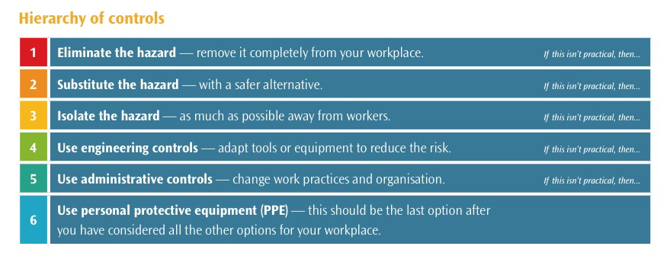

Hazard and Risk Assessment:

|  |  |  |  |  |  |
| --- | --- | --- | --- | --- | --- |
| IMPACT | LIKELIHOOD | | | | |
| Rare (1) | Unlikely (2) | Possible (3) | Likely (4) | Almost Certain (5) |
| Catastrophic (A) | M | M | H | C | C |
| Major (B) | L | M | M | H | C |
| Moderate (C) | L | M | M | M | H |
| Minor (D) | L | L | M | M | M |
| Insignificant € | VL | VL | L | L | M |

|  |  |
| --- | --- |
| Risk level | Required action |
| Critical | Act immediately:  The proposed task or process activity must not proceed. Steps must be taken to lower the risk level to as low as reasonably practicable using the hierarchy of risk controls. |
| High | Act today:  The proposed activity can only proceed, provided that:  (i) the risk level has been reduced to as low as reasonably practicable using the hierarchy of risk controls;  (ii) the risk controls must include those identified in legislation, Standards, Codes of Practice etc.  (iii) the risk assessment has been reviewed and approved by the Supervisor and  (iv) The supervisor must review and document the effectiveness of the implemented risk controls. |
| Medium | Act this week:  The proposed task or process can proceed, provided that:  (i) the risk level has been reduced to as low as reasonably practicable using the hierarchy of risk controls;  (ii) the risk assessment has been reviewed and approved by the Supervisor. |
| Low | Act this month:  Managed by local documented routine procedures which must include application of the hierarchy of controls. |
| Very Low | Keep a watching brief:  Although the risk level is low the situation should be monitored periodically to determine if the situation changes. |

|  |  |  |  |
| --- | --- | --- | --- |
| Hazard | Consequence | Likelihood | Risk Level |
| Exposed Wiring | Catastrophic | Almost Certain | Critical |
| Cords / Tripping | Major | Likely | High |
| Wet floors | Catastrophic | Likely | Critical |
| Damaged Protective Equipment | Catastrophic | Almost Certain | Critical |
| Long period at machine resulting in eye strain | Insignificant | Possible | Low |
| Accidents during pack up | Moderate | Possible | Medium |
| Lifting heavy objects | Moderate | Likely | Medium |
| Chemical Storage | Major | Likely | High |
| Inadequate Lighting | Minor | Unlikely | Low |

|  |  |
| --- | --- |
| Workplace location: | Office |
| Name of person conducting assessment: | Bill Cosby |
| Date: | 3/4/19 |

|  |  |  |  |  |  |  |  |  |  |  |
| --- | --- | --- | --- | --- | --- | --- | --- | --- | --- | --- |
| S | Spot the hazard | | A | Assess the risk | F | Fix the problem | | | E | Evaluate results |
| Identify the work task or activity | | What are the hazards associated with each activity or the steps in each activity | Is the risk associated with the hazard low, moderate, significant or high? | | If the risk is deemed unacceptable for the task, what will be done to reduce or remove the risk? | | By whom? | By when? | Go through the first 3 steps again to ensure risk levels are now at an acceptable level | |
| Revised risk level | |
| Using a computer. | | Eye strain. | Low | | Enforce breaks. | | Bill | This week. | Low. | |
| Walking to the printer. | | Tripping hazards, cords spread across walkways. | High | | If possible move the cords away from walkways or place a safety mat over them. | | Bill | Today | Low. | |
| Cleaning desks and monitors using chemicals | | Spilt chemicals, storage of chemicals. | High | | Enforce appropriate chemical storage and ensure that they are kept in a secure place that won’t lead to it being spilt. | | Dave | Today | Moderate. | |
| Cleaning the floors | | Wet floors. | High | | Clearly show wet floor areas with hazard signs. Ensure that a second dry mop is used. | | Bill | Today | Low. | |

Training Plan for Workers:

Yeet Ltd is committed to providing appropriate training to ensure workers have the skills and knowledge necessary to fulfil their WHS obligations. WHS training is a fundamental requirement for Yeet Ltd to achieve a safe workplace.

The following induction checklist should be used in conjunction with the general induction training program for workers to ensure that all new workers are aware of the WHS systems, policies and procedures in place within Yeet Ltd.

|  |  |
| --- | --- |
| Workplace: Yeet Ltd | |
| Date: 3/4/19 | Completed by: Bill Cosby |

|  |  |  |  |  |
| --- | --- | --- | --- | --- |
| Control measures | What training is required? | Who is to be trained? | How? | Date completed |
| Taping cords or placing a mat over them | Cord Management | Jeff Stan | Cord placement and tripping preventatives will be taught. | 1/2/19 |
| Hazard signs and misplacement of chemicals | Cleaning Procedures | Yousef Pled | Correct cleaning procedures, including where chemicals are kept will be taught. | 4/2/19 |
| Replacement of bulbs | Adequate light and their affect. | Fred Lead | Identification of inadequate light and how to fix the issue. | 7/2/19 |
| Installing plug sockets to avoid overloading | Electrical safety | Tod Huewad | Understanding the max amount of inputs into one socket are. | 12/2/19 |